**Apical Reform pays tribute to MB&F M.A.D.gallery’s ICONIC STATUs with mesmerizing kinetic art sculptures, during dubai Design week**

*“Tornado” and “Stingray” kinetic sculptures combine mechanics, hypnotic movements and artistry: on display at AR Gallery by Apical Reform and MB&F M.A.D.Gallery from 12th November – 30th December 2018*

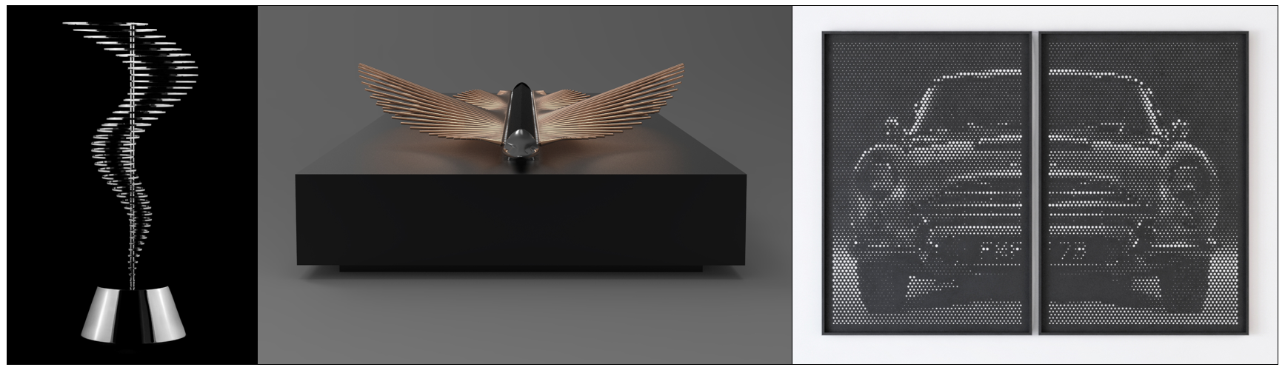

**Dubai, UAE – 21st October 2018:** Apical Reform has collaborated with MB&F M.A.D.Gallery to create two kinetic art sculptures that are inspired by the ethos of mechanical art and pay tribute to the pioneering spirit of the MB&F M.A.D.Gallery. The two limited edition mechanical art pieces entitled “Tornado” and “Stingray” embody the aesthetics of using mechanical motion and movement, to convey artistic expression and will be launched during Dubai Design Week. A third piece entitled “Schermo” will also be on display, which pays homage to the mechanical prowess of supercars, and focuses on the play between light and movement. The limited edition art works will be on display from 12th November – 30th December 2018 at both AR Gallery by Apical Reform in d3 and MB&F M.A.D.Gallery in Dubai Mall.

The “Tornado” kinetic sculpture has a distinct and impactful movement created through the geometric positioning of circular metal rings. Mimicking the power and rhythmic rise and fall of one of nature’s most beautiful natural phenomena, the fluidity of a whirlpool is brought to life through precise design and engineering, where axially linked discs are set in to action, creating a seemingly endless current. A metaphor for time – cyclic and yet, ever moving – this work of kinetic art is the centerpiece of the first collaboration between Apical Reform and MB&F M.A.D.Gallery. Tornado is available in 88 limited edition stainless steel pieces, with a mirror finish and 88 limited edition stainless steel pieces with a black gloss finish.

“Stingray” completes the synergy between art, mathematics, mechanics and electronics. Seeking its inspiration from the mighty stingray, this abstract kinetic sculpture pays reverence to the majesty of nature and captures the beauty and trance-like movement of the stingray in slow motion. Slowly accenting each gesture and movement, the on-looker is left mesmerized by the hypnotic and trance-like movement of the stingray, while its reflective finish creates a memorable aesthetic. Stingray is available in 8 limited edition pieces (and 2 artist proofs) in charcoal grey and rose gold color.

Supercars have always held prime position at the MB&F M.A.D.Gallery and the unmistakable form of Ferrari GTO 250, Aston Martin DB5 and Lamborghini Miura 1966-1973, provided great inspiration for “Schermo”. Transforming these iconic high performance vehicles via precise perforations on metallic plane, the final art work is a seemingly dynamic artwork, that whilst remaining static, responds to the movement of light, results in a surprising inter-play of perception, depth and dimension, leaving the onlooker surprised and captivated.

“The MB&F M.A.D. Gallery prides itself on being a haven for kinetic art and offering a captivating universe where mechanical masterpieces reign supreme. We are very pleased to welcome Apical Reform into our world and excited to showcase their pieces, which have not only been created exclusively for our Dubai gallery, but also seamlessly fuse technical expertise with artistic flair,” said Maximilian Büsser, Founder and Curator of MB&F M.A.D.Gallery.

“Since childhood I have been fascinated by moving objects, and that fascination grew into an appreciation of horology and kinetic design. MB&F M.A.D.Gallery is a pioneering gallery within the kinetic world and we are thrilled to be working with them. I have admired them from afar and to get an insight into the mastery of their futuristic art works, that are still deeply rooted in traditional craftsmanship, is both eye-opening and a childhood dream come true,” said Amrish Patel, Founder and Principal, Apical Reform.

**Click** [**HERE**](https://youtu.be/-mIlg3dl7eA) **to view the “Tornado” video.**

**Click** [**HERE**](https://youtu.be/zgoH5hX8dYI) **to view the “Stingray” video.**

For further information please visit [www.madgallery.ae](http://www.madgallery.ae) or www.apicalreform.com

– END –

**About the M.A.D.Gallery:**

The MB&F M.A.D.Gallery is a captivating universe of kinetic art where Horological Machines and Mechanical Art Devices reign supreme. The first M.A.D.Gallery opened in 2011 in Geneva on Rue Verdaine, a stone’s throw from MB&F’s offices and atelier in the heart of the city’s old town. A second location opened in 2014 in Taipei then a third in Dubai in 2016. Inside the galleries, you have the pleasure of discovering carefully-curated pieces – or, as we like to call them, Mechanical Art Devices – from around the world, each one making your heart beat that little bit faster. You exhale, only then to find the complete range of MB&F Horological Machines and Legacy Machines.

**About AR Gallery**

A blank canvas for innovation in interiors, product design and creative arts, AR Gallery moves beyond traditional roles of a gallery to provide infrastructural assistance to creative product brands and designers - established and emerging, regional and international, with the ultimate aim of pushing the limits of the creative industries.

Conceived by Amrish Patel, founder of the progressive design studio Apical Reform, AR Gallery’s vision is backed by industry knowledge, high-tech production capabilities and an intention to build bridges between talent, opportunity and audiences.

Fostering an environment that is geared to nurture and promote, ARGallery at Building Six, Dubai Design District, UAE also undertakes design projects and commissions under the guidance of its partner and director, the award-winning designer Anna Szonyi.

@argallery.dxb

[www.argallery.ae](http://www.argallery.ae/)

**About MB&F:**

Based around one very simple and fundamental ideal: to assemble dedicated collectives of talented horological artisans, artists and professionals – all friends – to design and craft each year a radical and original horological masterpiece. By nurturing teams of talented individuals, harnessing their passion and creativity and crediting each individual's essential role, MB&F uses their synergy to become much greater than the sum of its parts. MB&F is above all a human adventure... a human adventure with just one goal: to create incredible horological machines. 13 years of hyper-creativity; 14 remarkable calibres forming the base of the critically acclaimed Horological Machines and Legacy Machines for which MB&F has become renowned.

**About Apical Reform**

Founded in 2011, Apical Reform is a collaborative design studio dedicated to creating immersive experiences led by art and innovation in production technology.

In just a few years, the studio has found a definitive creative voice, designing everything from collectible furniture to bespoke design-art pieces. The studio consists of a group of young, forward-thinking creatives making an honest inquiry into how design intervention can transcend the mundane into a singularly extraordinary experience. Innovation and technology are the foundations from which the Apical Reform designers approach their métier.

Principal and founder Amrish Patel’s vision is fuelled by a constant endeavour to seek the highest order of quality with an innate design sensibility. Director Darshan Soni received his architectural education from one of the most respected design schools in Asia, the Centre for Environmental Planning and Technology (CEPT), India. An avid photographer, Soni finds his inspiration in multiplicity and parametric designs. Together, the duo guides the studio to manifest one-of-a-kind design objects that go beyond their material worth. By lending a poetic quality to life, these works are design icons of the future.

Apical Reform is based in India, and AR Gallery was inaugurated in Dubai Design District (d3) in 2017.

**About Ahmed Seddiqi & Sons:**

Curators of time since 1950, Ahmed Seddiqi & Sons is the Middle East’s most trusted destination for luxury watches and jewellery. Recognised today as a pioneer among the leading retailers in the region, the family owned-and-run company represents more than 60 luxury timepiece brands across 65 locations in the UAE.

An advocate of horology in the region’s retail landscape, Ahmed Seddiqi & Sons continues to create sustainable platforms for watchmaking and servicing, supporting watch enthusiasts and collectors in the region to increase their passion and understanding of the art of timekeeping.

Ahmed Seddiqi & Sons prides itself in offering unparalleled customer service across pre and post-sale dimensions. Led by the passion and credibility of the second, third and fourth generations of Seddiqi family members, the organisation delivers a dynamic commitment to preserving and enhancing the preservation, creation and innovation of watchmaking for decades to come.

[www.seddiqi.com](http://www.seddiqi.com)

M.A.D.Gallery Dubai

Address: Fashion Avenue Extension, The Dubai Mall, Dubai, U.A.E

Tel.: +971 4 388 2554

[info@madgallery.ae](mailto:info@madgallery.ae)

M.A.D.Gallery Geneva

Address: Rue Verdaine 11, 1204 Geneva, Switzerland

Tel.: +41 22 508 10 38

[info@madgallery.ch](mailto:info@madgallery.ch)

M.A.D.Gallery Taiwan

Address: 1F, No.2, Aly 232, Sec 1,

Dunhua S Rd, Da'an Dist,

Taipei 106, Taiwan

Tel.: +886 2 2775 2768

[madgallery.taipei@swissp.com.tw](mailto:madgallery.taipei@swissp.com.tw)

Follow M.A.D.Gallery Dubai

[www.madgallery.ae](http://www.madgallery.ae)

Facebook: MB&F MAD.Gallery Dubai

Instagram: mbfmadgallery.ae